**EQUITY GROUP POSTS PROFIT AFTER TAX GROWTH OF 20%**

*Nairobi 10th May 2016…* Regional financial services provider Equity Group has reported a 20% year on year profit growth for the period ended 31st March 2016.

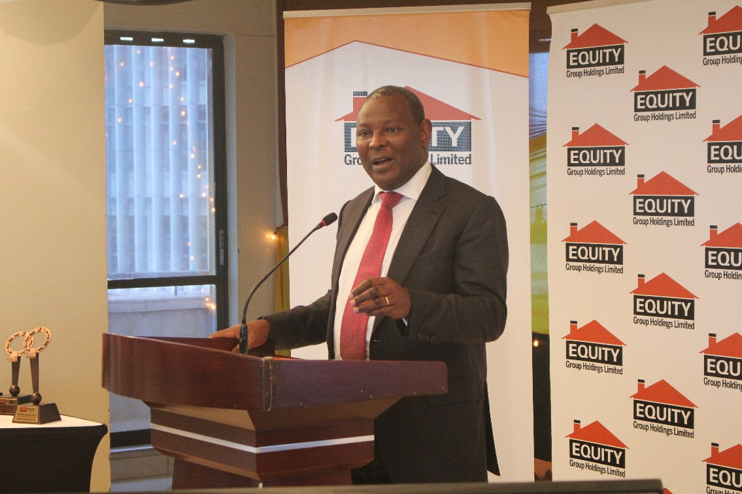

Profit before tax increased from Khss.6.1 billion to Kshs.7.3 billion while profit after tax rose from Kshs.4.3 billion to Kshs.5.1 billion for the same period last year.

The Group profit has been delivered by a 22% growth in loan book and a 28% growth in government securities. Net loans grew from Kshs.225 billion to Kshs.275 billion while government securities grew from Kshs.49 billion to Kshs.62 billion. The balance sheet and total funding grew by 16% from Kshs.373 billion to Kshs.430 billion.

The Group restructured its balance sheet to take full advantage of the prevailing micro economic environment to optimize on earning. Cash and cash equivalent which are non-earnings were reduced by 22% and deployed to investment in Government securities that grew by 28% to take advantage of the prevailing high interest rates on treasury bills and bonds of nearly 20% complementing a 22% growth in loan book to deliver a 36% growth in interest income and a growth of yield on interest earning assets from 12.5% to 14.5%.

On the liability side the Group restructured its funding by increasing long-term debt funds by 76% from Kshs.26 billion to Kshs.46 billion at an average cost of 3.5% helping to reduce cost of funding from 3% as at December 2015 to 2.8% thus enhancing net interest margin to 11.7% up from 9.9% the same period last year.

The Group maintained efficient operations driven by a high quality loan book. Non-performing loans stood at 3.8% against non-performing loans of 4.3% similar period last year. Other operating costs grew by 8% as a result of successful deployment of variable costs 3rd party delivery channels of Agency banking, Merchant banking and Mobile banking saving on fixed costs. The cost income ratio of Equity Bank Kenya which is leading in digitization reducing from 48% to 43% while the Group cost income ratio have reduced from 51% to 49% during the reporting period.

The declining cost income ratio supports an 18% growth in total income resulting in profit after tax growth of 20% for the period ended 31st March 2016, enhancing return on average Equity to 29.1% up from 27.6% while Return on Average Assets has stabilized at 4.8% year on year.

The solid performance of the Group has enhanced the shareholders capital position resulting in core capital to risk weighted assets ratio growing to 18.3% up from 16.2% while total capital to risk weighted assets ratio has improved to 19.6% up from 18.2% and core capital to deposits ratio has improved to 24.2% up from 18.8% due to the successful restructuring of the balance sheet which has also enhanced performance.

The performance has benefited from the Group’s strong brand that has seen the number of customers grow to reach 10.3 million. The huge customer base provide a diversified risk base avoiding concentration of risk.

Strong governance structure that outlaw insider trading and borrowing by directors with a strong code of conduct and ethics, a speak out policy and a proactive intelligence risk culture of accountability have differentiated the bank and given public confidence at a time the banking industry is going through challenging times.

The improving micro economic environment characterized by declining inflation, declining current account deficit, stable foreign exchange and declining interest rates is likely to spur continued growth. Improvement in security and as a result the tourism sector better weather patterns with sustained good rainfall spurring agriculture and increased foreign direct investments and continued investments in infrastructure provide an opportunity for improved business opportunity.

Equity Bank emerged the best overall bank in Kenya in the 2016 Think Business Awards, retaining that position for the 4th time. The Bank was also named the best Bank in Agency Banking, Microfinance, Retail Banking and SME Banking. The bank took 1st runners up position in customer satisfaction, mortgage finance, product marketing, internet banking and asset finance and 2nd runners up position as fastest growing bank and in mobile banking.